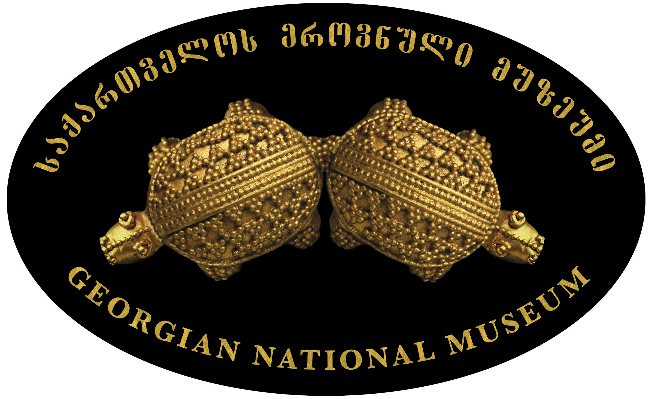
- June 17 and 22 Public Lectures: Jazz for Youth
Organizers:
Georgian National Museum, Radio Syndicate Eastern Promotion and US Embassy
VENUE: Georgian National Museum, 1 Purtseladze Street

Georgian National Museum, Radio Syndicate, Eastern Promotion Company and the US Embassy are partnering to popularize jazz among Georgian youth, to draw their attention to jazz as a living treasure, as well as to encourage musicians, schools, museums, public broadcasters, to offer programs on jazz. Through public lectures the organizers intend to stimulate the current jazz scene and encourage young people to study jazz, attend jazz concerts and listen to jazz.
Public lectures will be held at the Georgian National Museum’s newly renovated auditorium.

saqarTvelos erovnuli muzeumis, radio sindikatis, kompania EASTERN PROMOTION-is da aSS saelCos erToblivi proeqti jazi axalgazrdebisTvis, miznad isaxavs qarTvel mozardebsa da axalgazrdebSi interesebis sferos gafarTovebas, jazis mdidari kulturuli tradiciebis gacnobas da jazis popularizacia.s
proeqti ganxorcieldeba saqarTvelos erovnuli muzeumis auditoriumSi ivnisSi dagegmili koka-kola Tbilisis jaz festivalis farglebSi. Sexvedrebze axalgazrdebs gaacnoben festivalSi monawile cnobil musikosebsa da Tanamedrove jazur mimdinareobebs.

